Blackberry Smoothie
(Adapted from the real food diet cookbook by Dr. Josh Axe)
You can find Dr. Axe's cookbook at the link below:
http://www.amazon.com/Real-Food-Diet-Cookbook-Josh/dp/0615386660

Ingredient Ideas:

1 ½ cups of Coconut Milk
1 ½ cups of Frozen Blackberries
1 cup of Frozen Strawberries
½ teaspoon of Lime Juice
½ teaspoon of Maple Syrup

Throw all the ingredients together in a blender or smoothie maker. Blend until smooth.

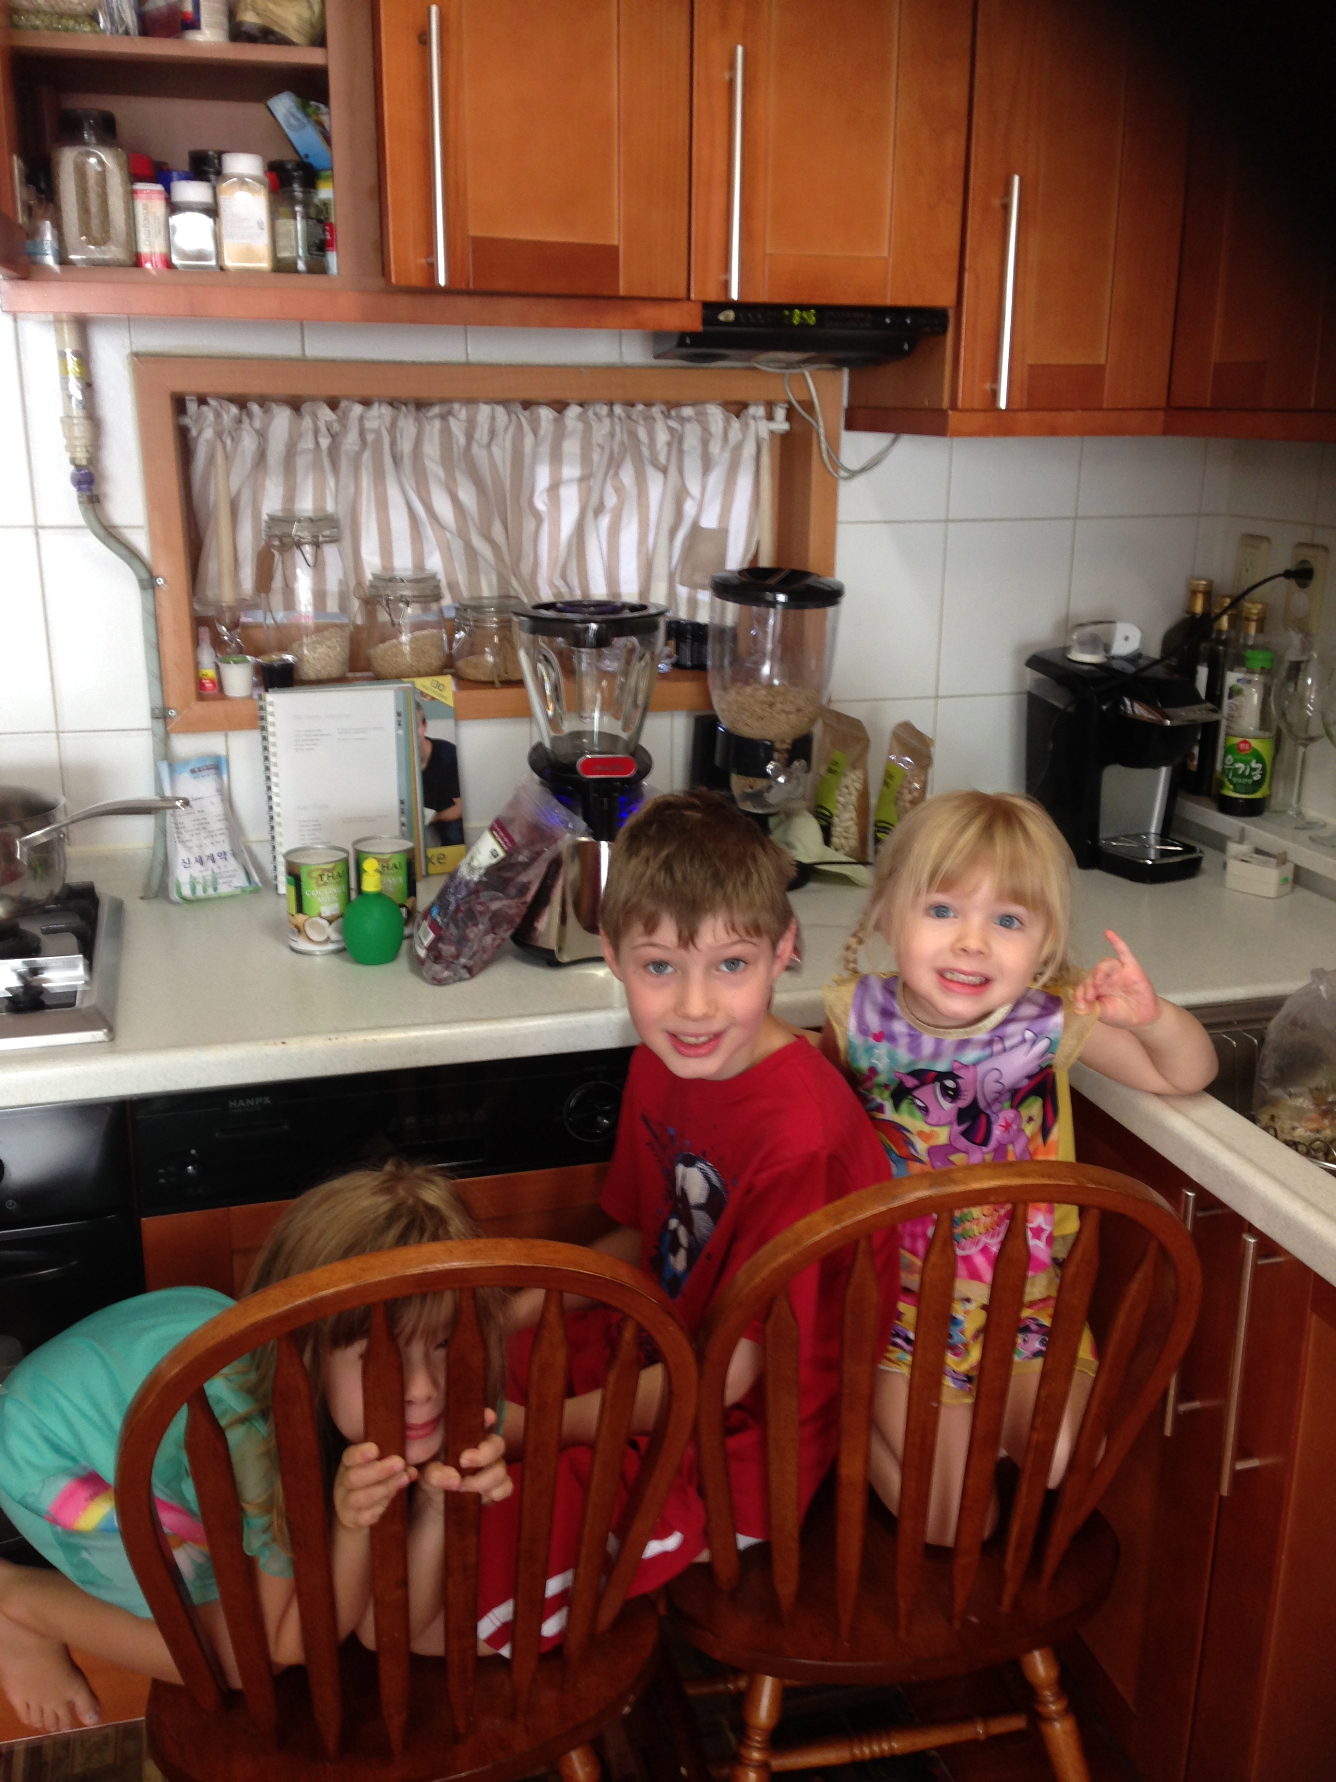

J.T., Aysia, and Ella enjoyed helping me make the blackberry smoothie. However, they did not enjoy drinking it as much! They did not care for the overshadowing coconut flavor the coconut milk brought. Next time, I will stick to organic yogurt for the liquid base for their smoothies

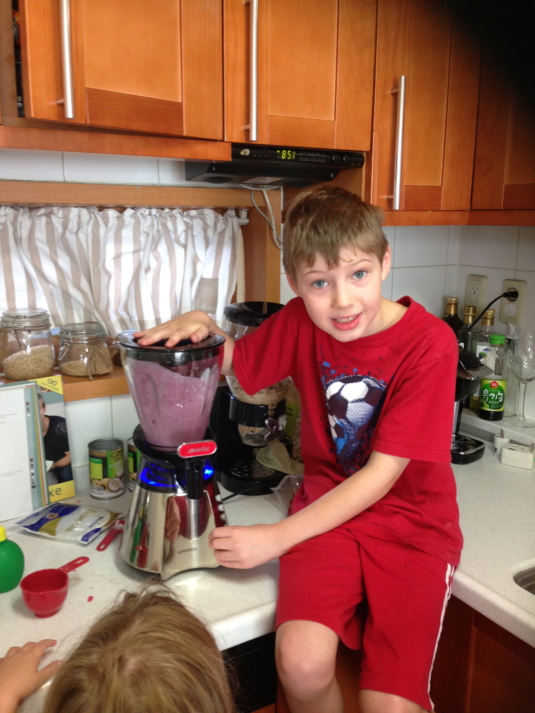

J.T. loves pushing the power button on our smoothie maker!

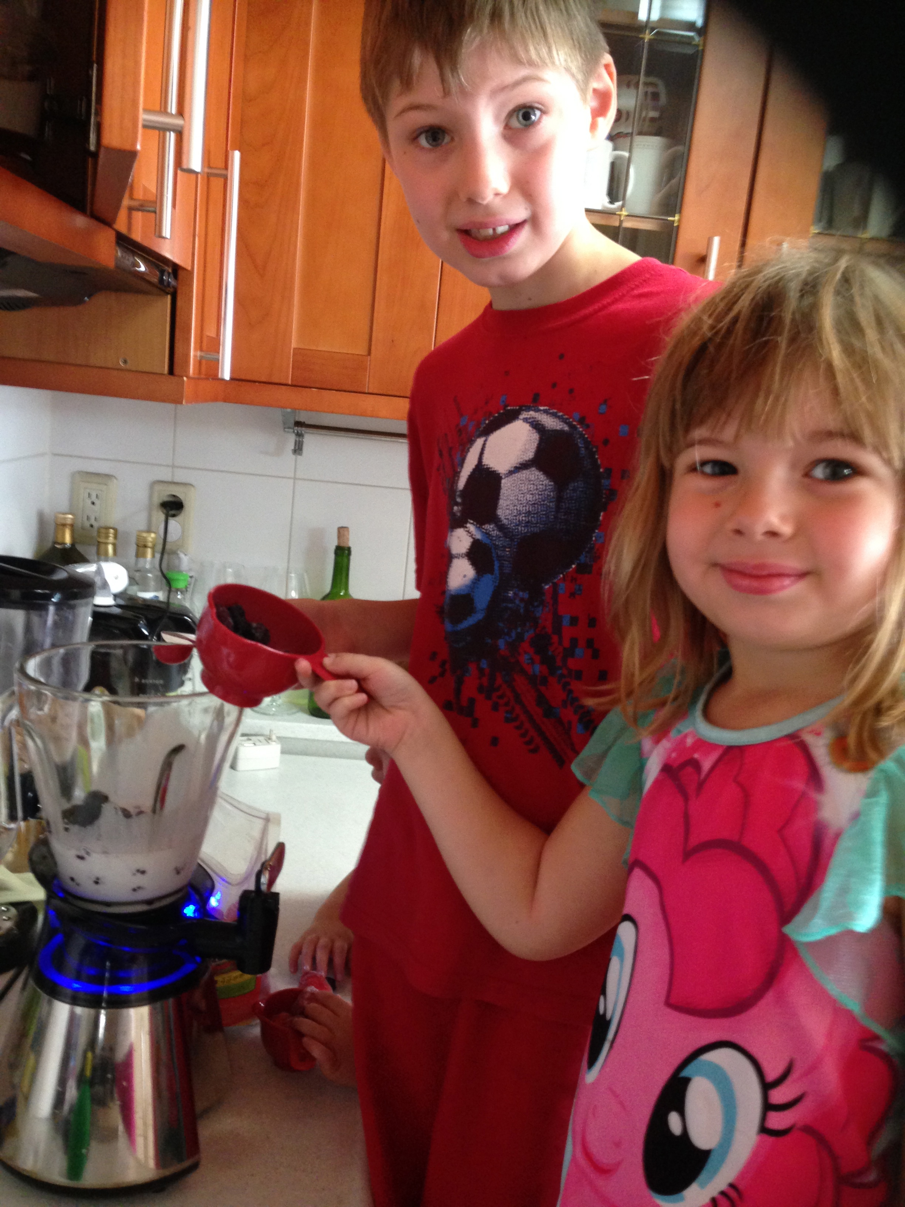
It was fun to let them pour the ingredients in since we had more time on Saturday morning.

I am an experimental cook in the kitchen; therefore, I may not write the exact amounts of ingredients or specific recipe instructions used. I encourage you to be a creative cook and enjoy adding your own personality to your dishes!

