Chicken Bryan
(Adapted from the real food diet cookbook by Dr. Josh Axe)

Ingredients:

Oil for cooking (I prefer coconut oil)
3-5 pieces of chicken breasts
Fresh minced garlic
3-4 tablespoons of butter
Lemon slices
A couple of handfuls of mushrooms
As many sun-dried tomatoes as you would like
3-5 leaves of fresh basil
Sea salt
3-4 tablespoons of goat cheese

Get started by heating your pan with oil on the stove. When your oil is at medium heat, add your chicken pieces and minced garlic. Allow to cook for 7-8 minutes. Before flipping chicken, add your butter and lemon slices to the pan, and allow to cook 5-6 minutes more. Then, add the rest of the ingredients except the goat cheese. When the dish looks almost ready to eat, add the goat cheese, cover, and allow to cook a couple more minutes!

*I am an experimental cook in the kitchen; therefore, I may not add the exact amounts of ingredients or specific recipe instructions used. I encourage you to be a creative cook and enjoy adding your own personality to your dishes!

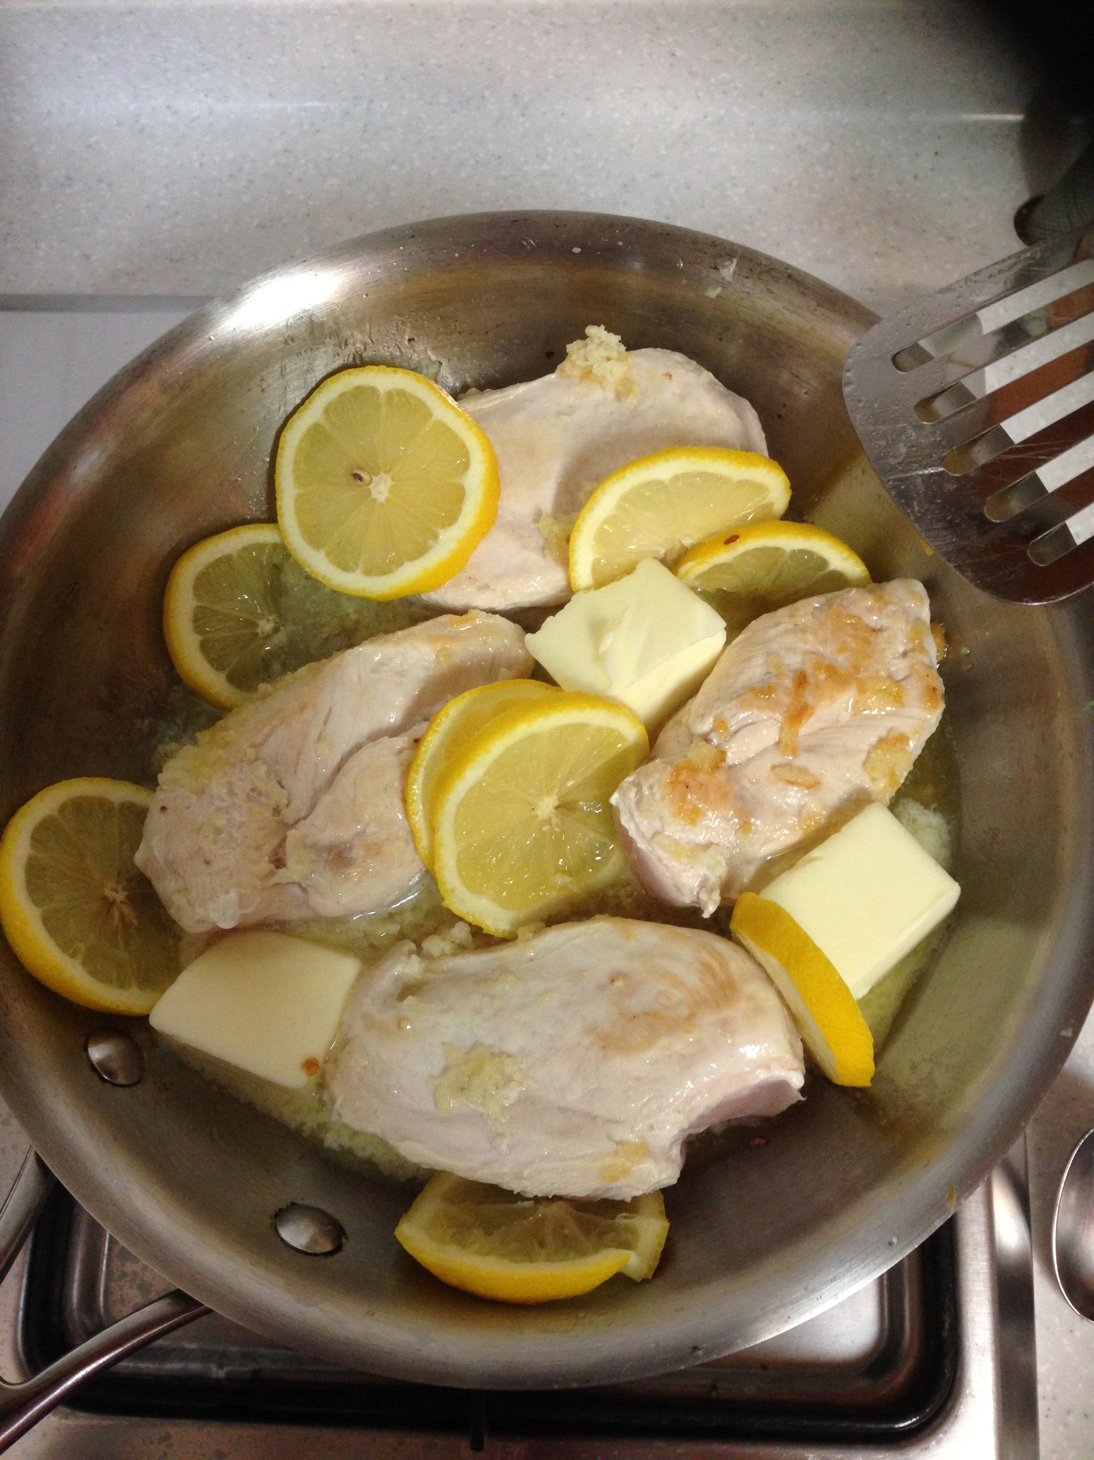
Chicken after adding butter and lemon

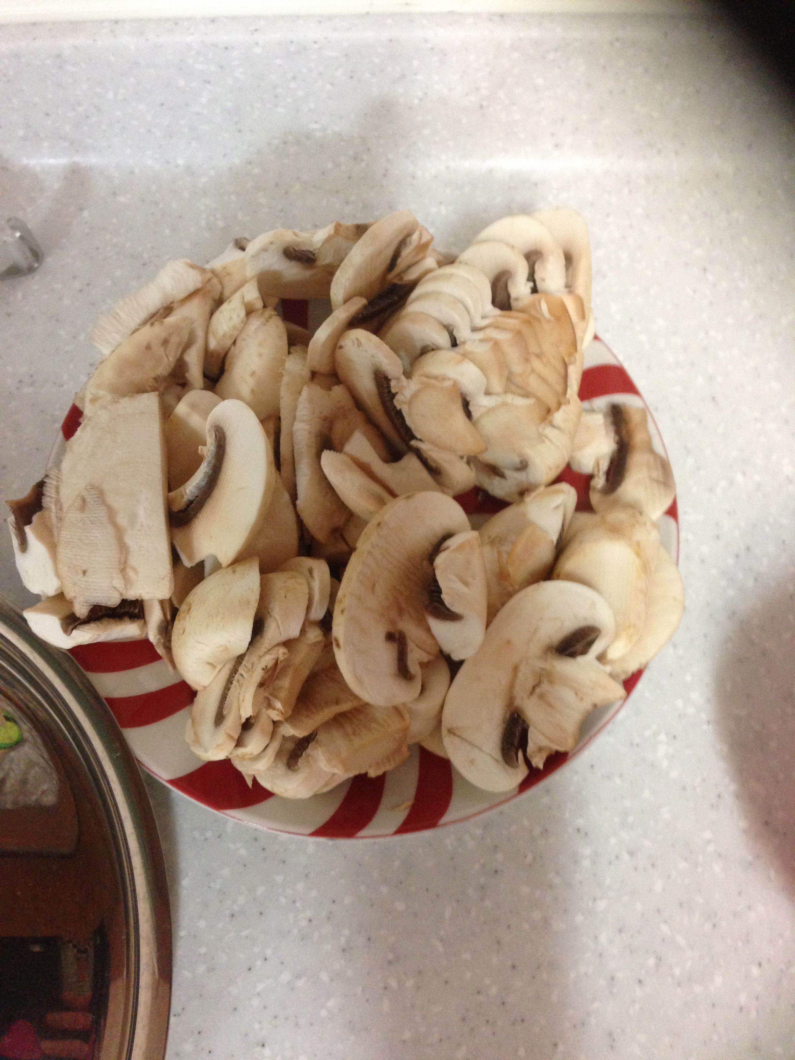
Fresh chopped mushrooms

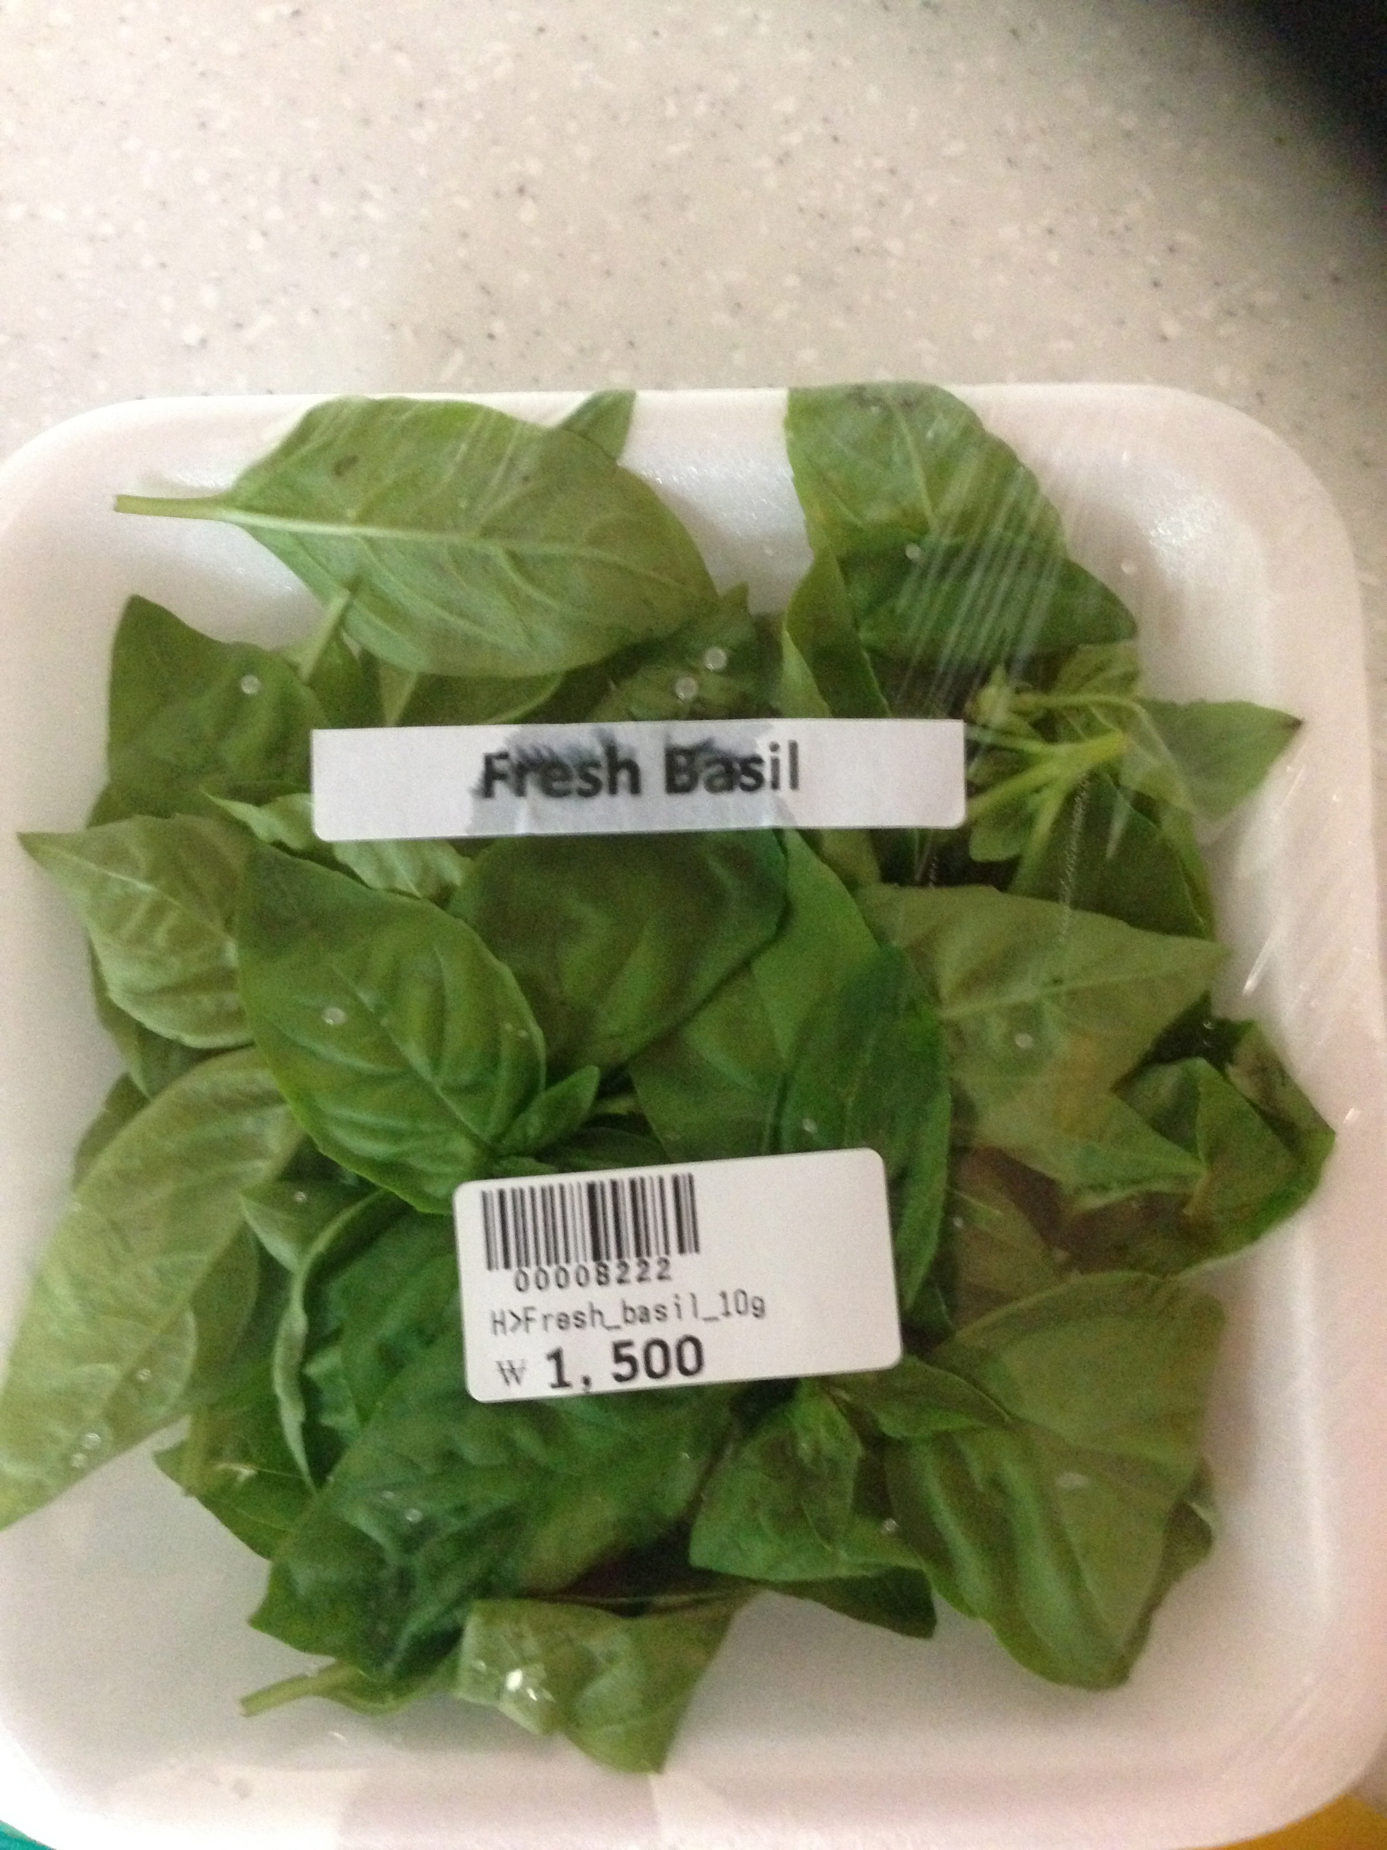
Fresh package of basil (bought at High Market)

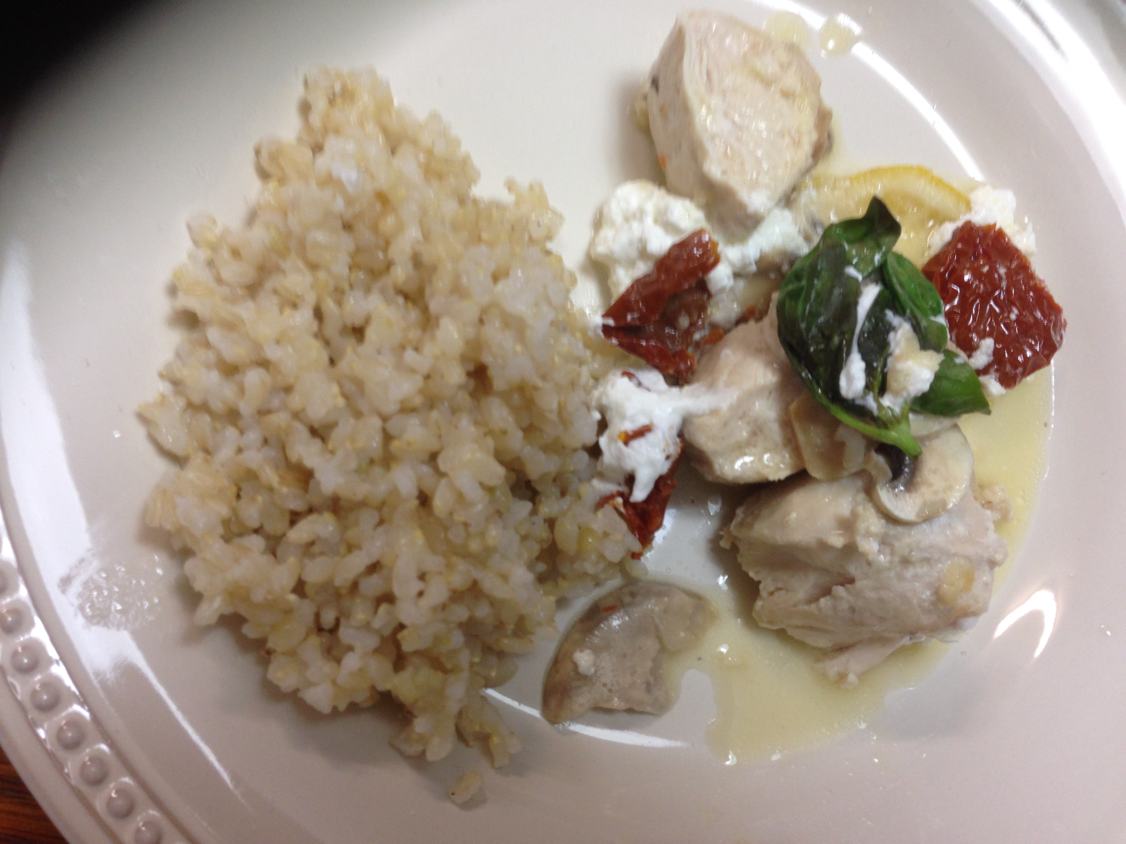
Chicken Bryan served with germinated brown rice

