Kale Shake
(Adapted from the real food diet cookbook by Dr. Josh Axe)
You can find Dr. Axe's cookbook at the link below:
http://www.amazon.com/Real-Food-Diet-Cookbook-Josh/dp/0615386660

Ingredients:

8-10 Kale Leaves
1 Peeled Banana
½ - 1 cup of Red Grapes
4-5 Ice Cubes
½ - 1 cup of Water

Add-In’s:

Ground Cinnamon
Maple Syrup

Add all ingredients to a blender or smoothie maker and blend until smooth!

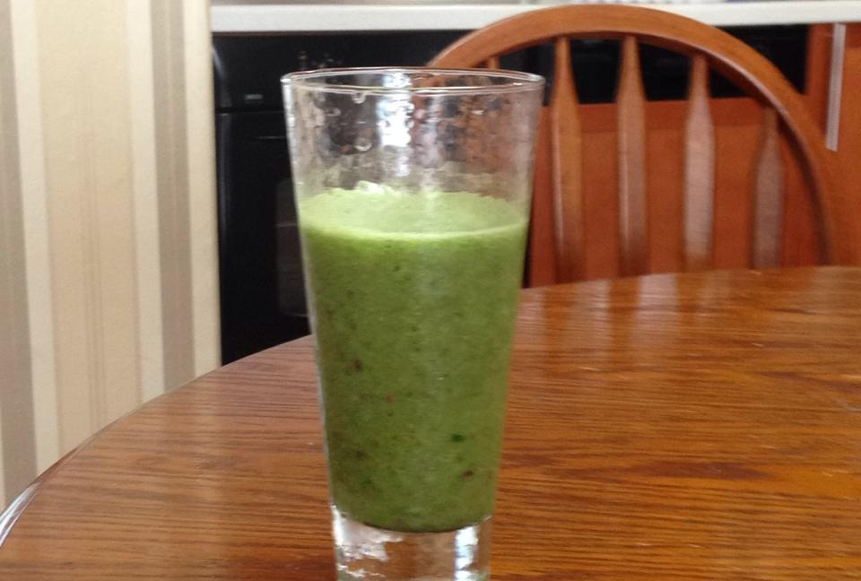

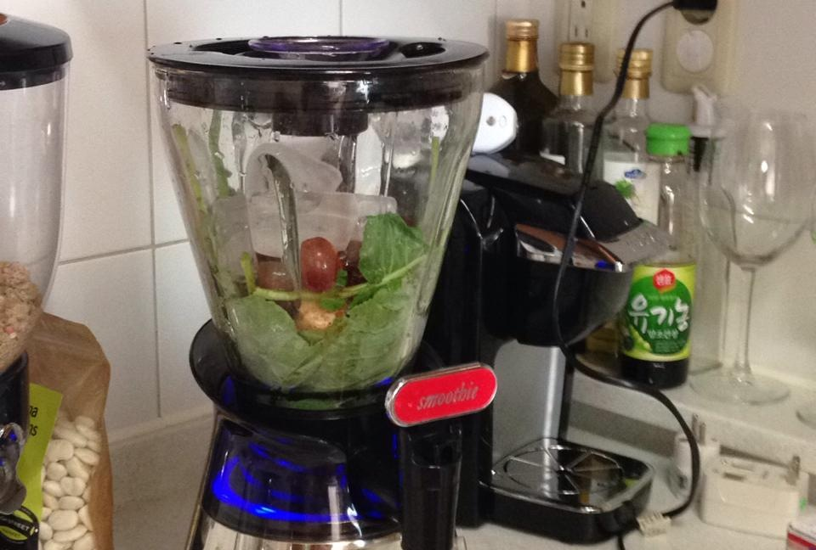

Let’s Blend!

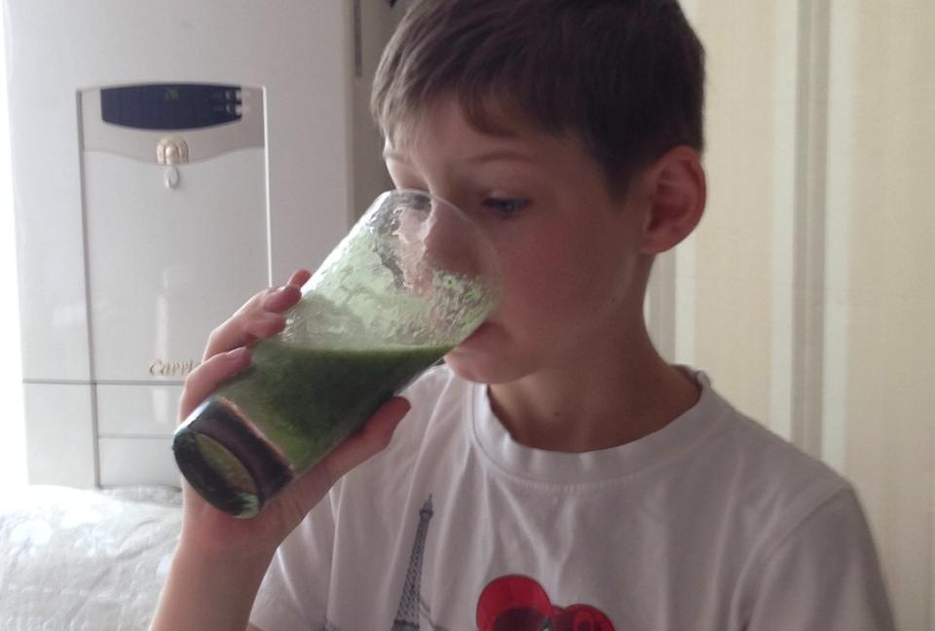

Challenging J.T. to try a GREEN smoothie!

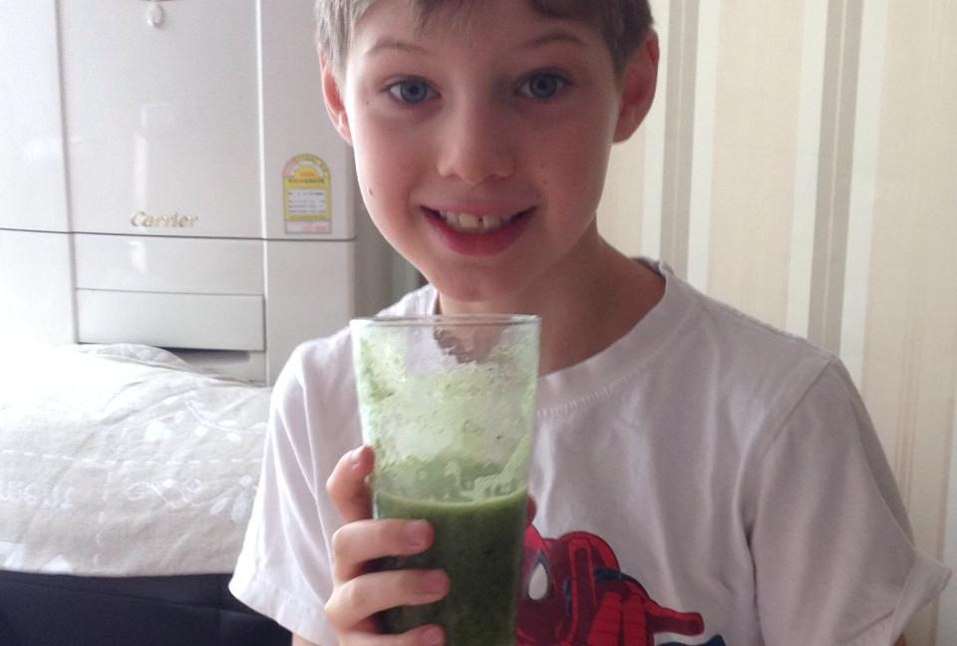

He likes it for the first few sips!

For all my Seoul friends, I bought Kale in the organic section of Emart. When you say Kale in Korean it sounds very similar to Kale in English! So, just ask for help if you cannot spot it!

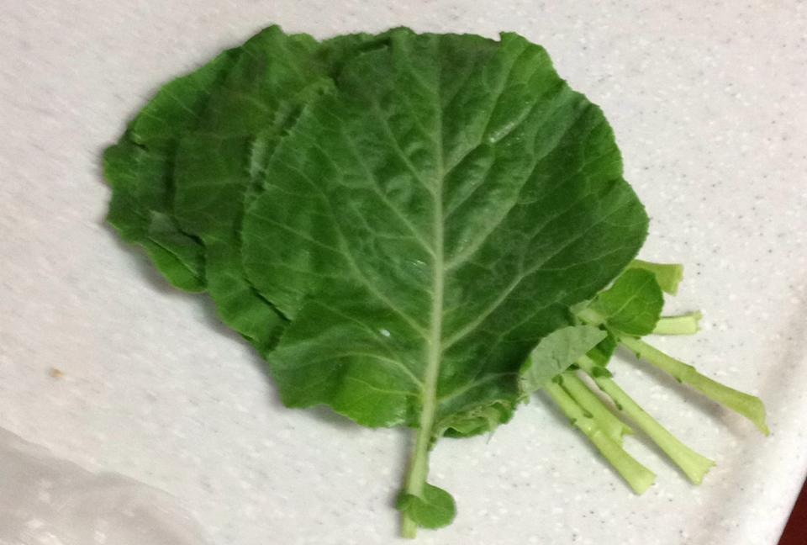
*I am an experimental cook in the kitchen; therefore, I may not write the exact amounts of ingredients or specific recipe instructions used. I encourage you to be a creative cook and enjoy adding your own personality to your dishes.

