Simple Fruit Smoothie

Ingredients:

FRUIT Ideas:

Frozen Strawberries
Frozen Blueberries
1 peeled deseeded lemon

Base Liquid Ideas:

Organic yogurt
Water

Add-in Ideas:

Flax Seed Powder
Chia Seeds
Maple Syrup

Throw all the ingredients together in a blender or smoothie maker. Blend until smooth.

I am an experimental cook in the kitchen; therefore, I may not write the exact amounts of ingredients or specific recipe instructions used. I encourage you to be a creative cook and enjoy adding your own personality to your dishes!

For all my Seoul Friends, I found frozen organic strawberries and frozen organic
blueberries at Cosco. 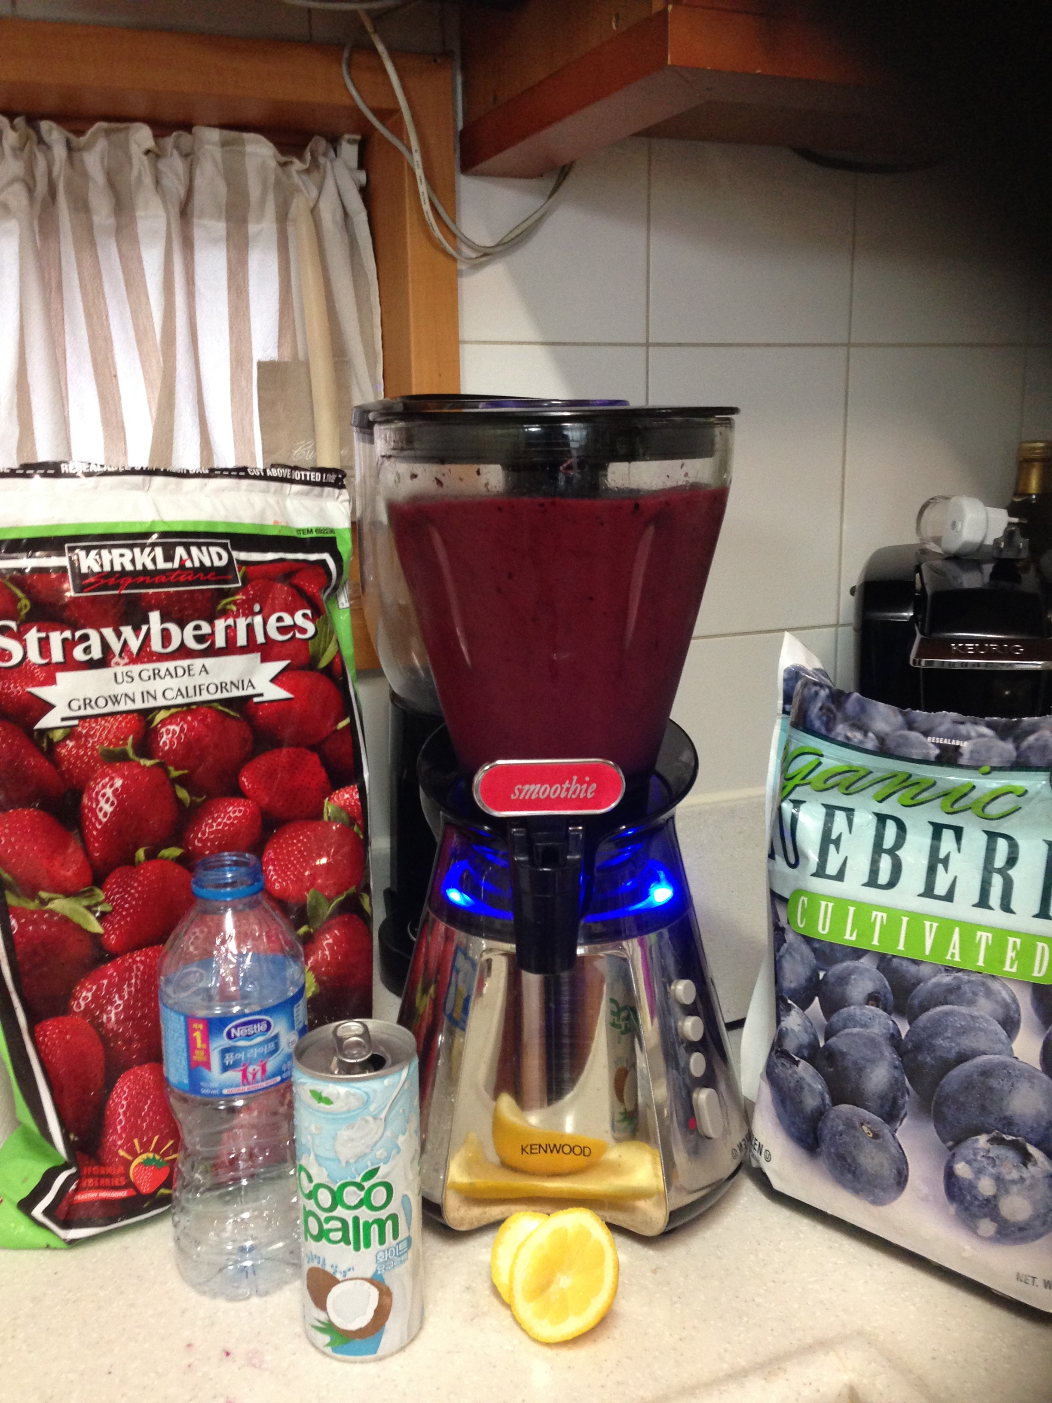

They also carry Chia Seed! 