Wild Rice and Spinach Soup
(Adapted from the real food diet cookbook by Dr. Josh Axe)

Ingredients:

1 tablespoon of butter
1 cup of cooked rice
(I like to use germinated brown rice)
1 chopped onion
1 chopped bell pepper
1 quart of chicken broth
2-3 chopped carrots
Spinach
Sea Salt and ground pepper

Over medium heat, melt butter in large pot. Add rice, onion, and bell pepper and cook until veggies are softened. Pour in chicken broth and cook until it begins to boil. Then turn heat to low and allow soup to simmer for 15 minutes, stirring occasionally. Next, throw in carrots, cover with a lid, and cook a little longer. Lastly, add spinach, salt and pepper, and cook a couple of minutes more before enjoying!

*I am an experimental cook in the kitchen; therefore, I may not add the exact amounts of ingredients or specific recipe instructions used. I encourage you to be a creative cook and enjoy adding your own personality to your dishes!
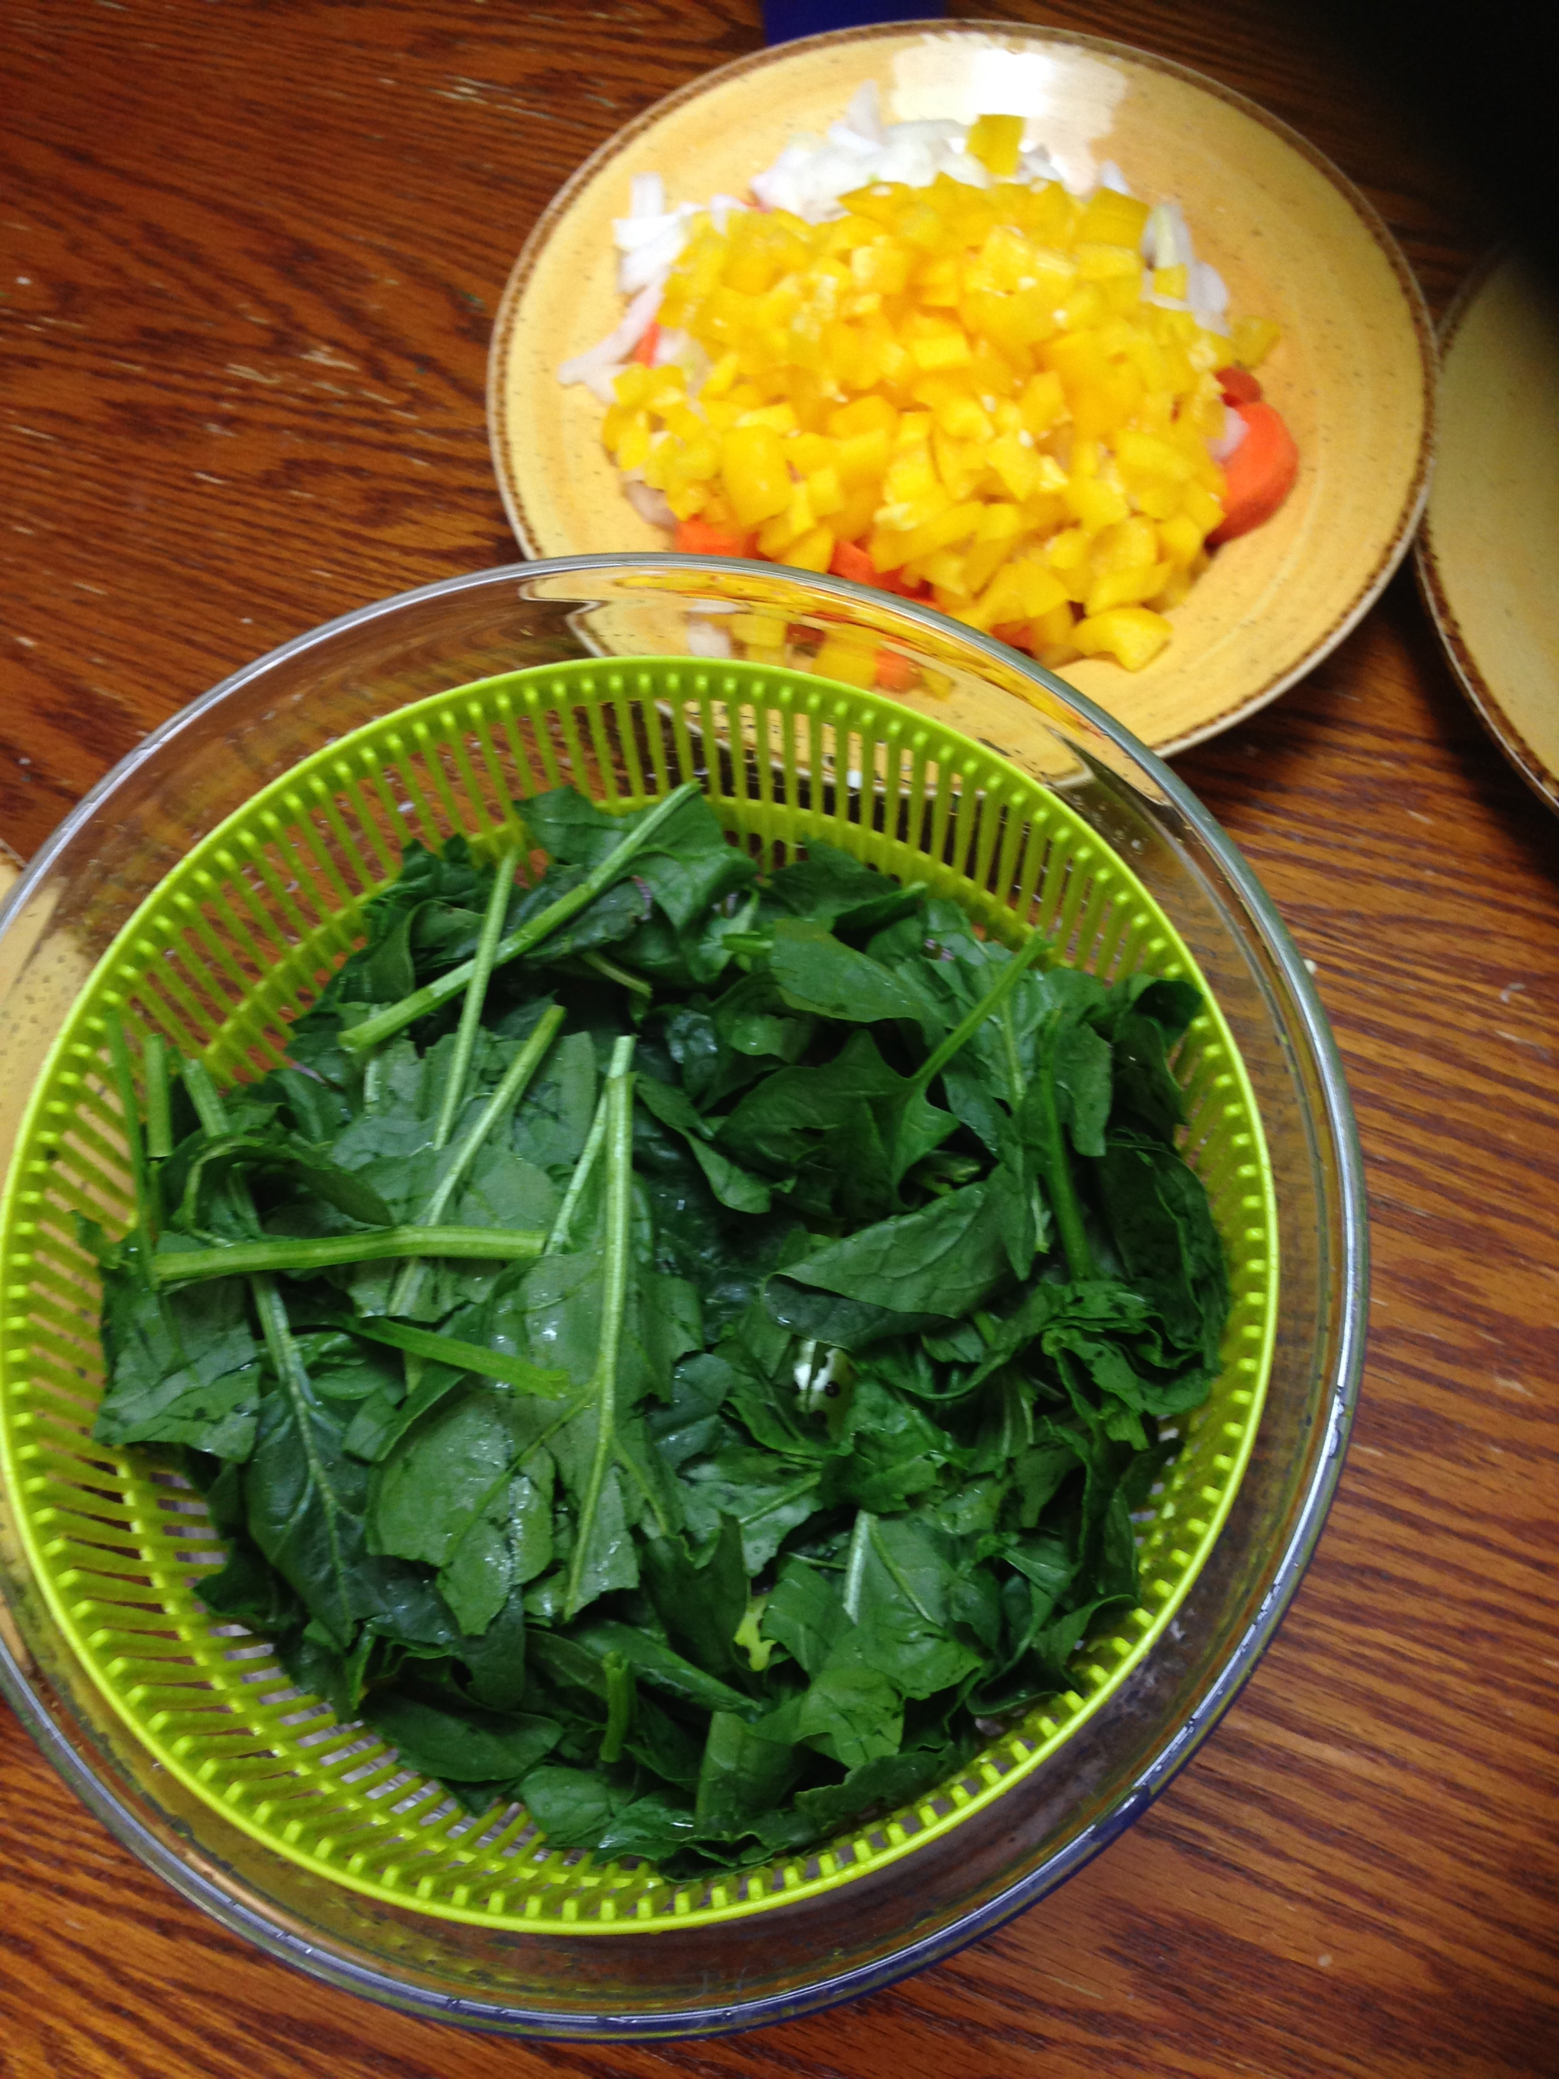

Chopped carrots, onion, carrots, and washed spinach

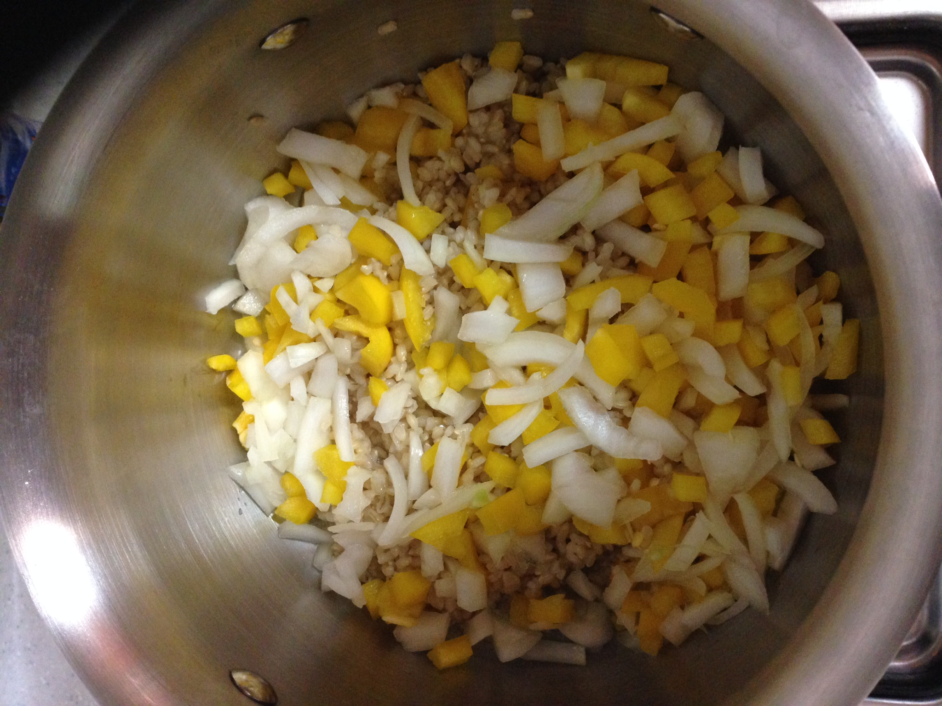

Rice, onions, and bell pepper stir frying in butter
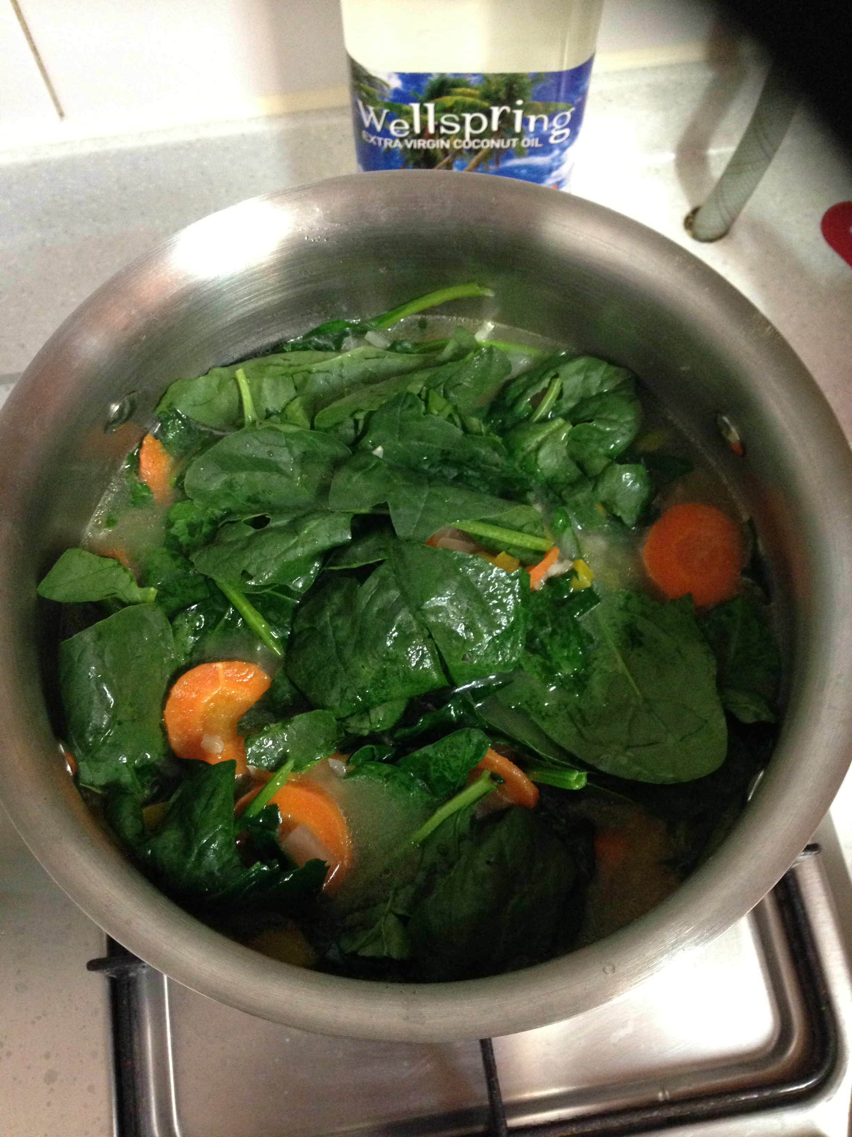

Just added spinach!

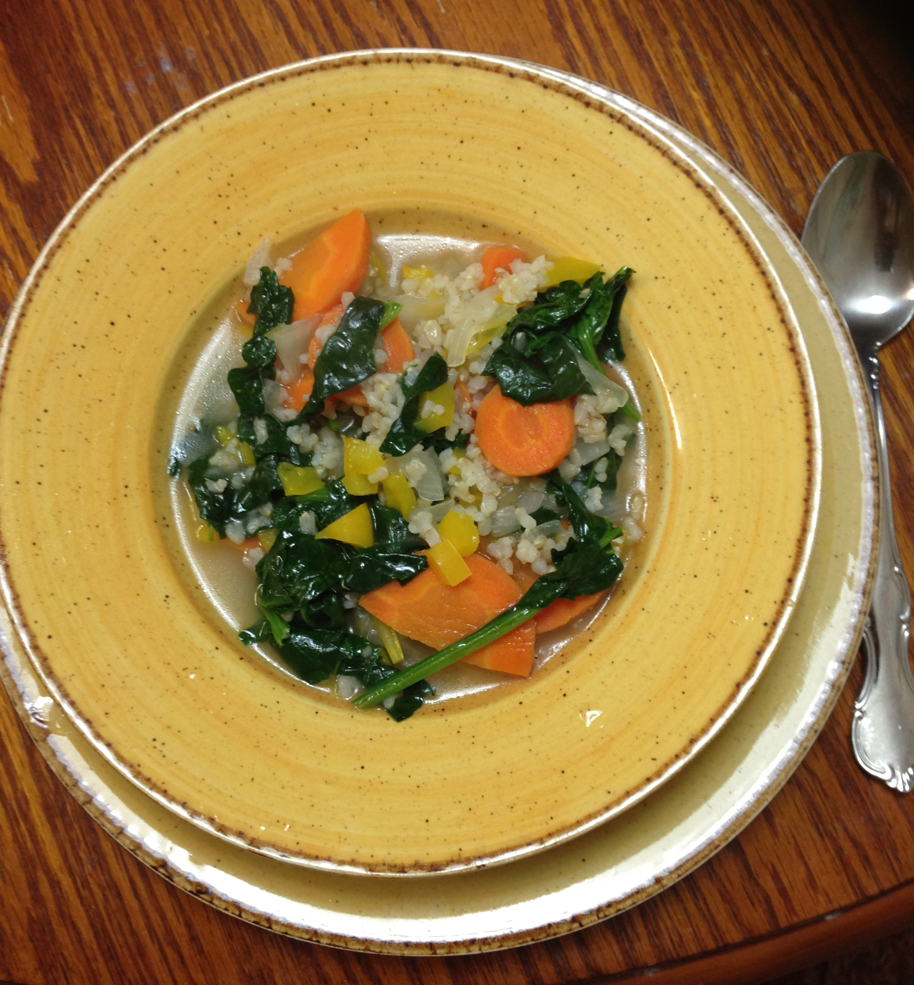

Wild Rice and Spinach Soup is ready to eat!

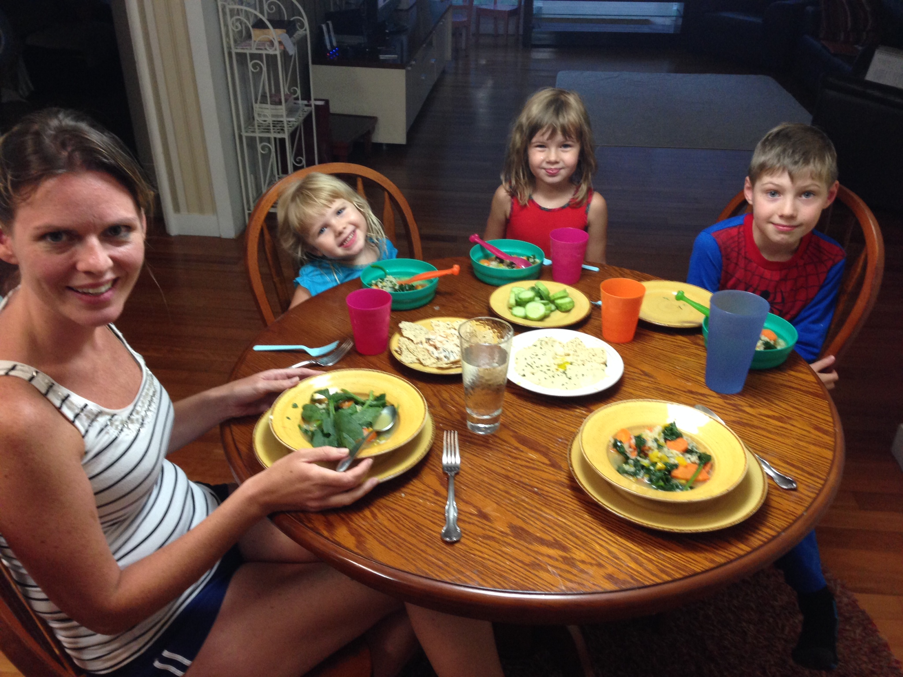

Time for the family to enjoy!

